SHULL SCIENCE · JAMES A. GARFIELD LOCAL SCHOOLS
UNIT 2 QUIZ B
QUIZ · VERSION B · ELECTRON CONFIGURATIONS AND IONS · TEACHER KEY
NAME | DATE | PERIOD | SCORE / 23

You may use a periodic table. For multiple choice, circle one letter. In an orbital diagram, each electron gets one arrow.

Part 1 Multiple choice | 3 points

1 | Which rule says two electrons in one orbital must have opposite spins? C Pauli, 2 per orbital, opposite
1 | A Aufbau principle | B Hund's rule | C Pauli exclusion | D Bohr model
2 | Which orbital diagram for oxygen's 2p⁴ follows Hund's rule? A spread out, then pair the 4th
2 | A | B | C | D
  ↑↓ | ↑ | ↑
  ↑↓ | ↑↓
  ↑ | ↑ | ↑
  ↑↓ | ↑ | ↓
3 | Which sublevel fills right after 3d? C 3d, then 4p
3 | A 4s | B 4d | C 4p | D 3f

Part 2 Longhand configurations and orbital diagrams | 8 points

4 | 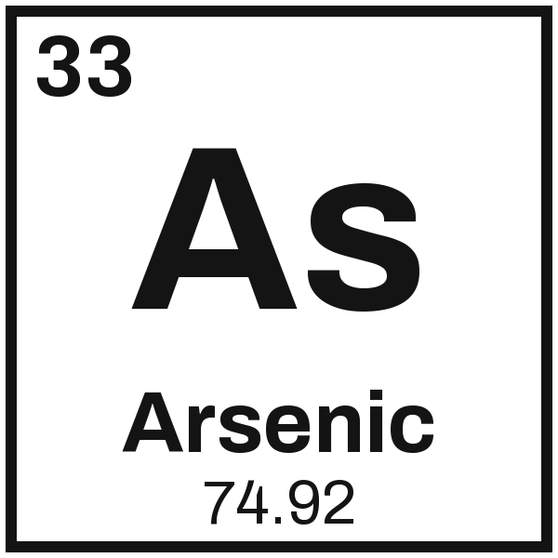 | Configuration 1s² 2s² 2p⁶ 3s² 3p⁶ 4s² 3d¹⁰ 4p³
4 |  | Orbital diagram
  1s | ↑↓ | 2s | ↑↓ | 2p | ↑↓ | ↑↓ | ↑↓ | 3s | ↑↓ | 3p | ↑↓ | ↑↓ | ↑↓ | 4s | ↑↓ | 3d | ↑↓ | ↑↓ | ↑↓ | ↑↓ | ↑↓ | 4p | ↑ | ↑ | ↑

5 | 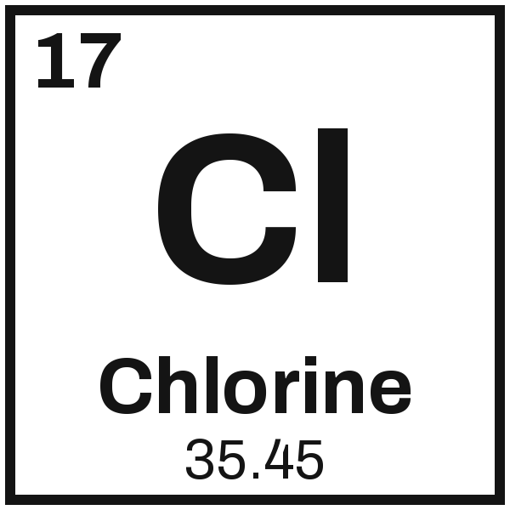 | Configuration 1s² 2s² 2p⁶ 3s² 3p⁵
5 |  | Orbital diagram
  1s | ↑↓ | 2s | ↑↓ | 2p | ↑↓ | ↑↓ | ↑↓ | 3s | ↑↓ | 3p | ↑↓ | ↑↓ | ↑

Part 3 Noble-gas shorthand | 4 points

6 | 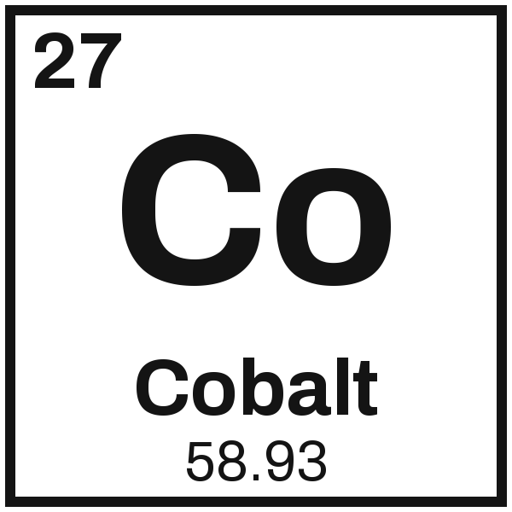 | [Ar] 4s² 3d⁷ | 7 | 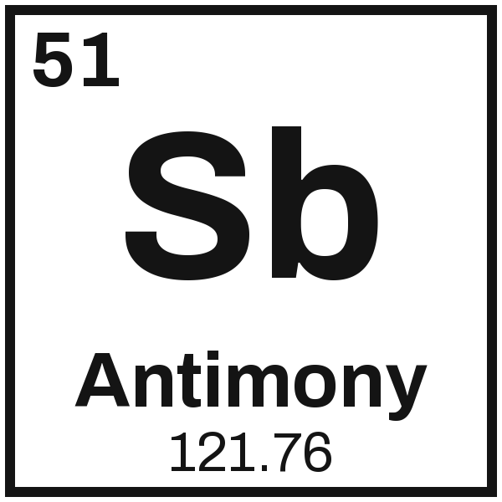 | [Kr] 5s² 4d¹⁰ 5p³

Part 4 Ions: the charge, and cation or anion | 8 points

8  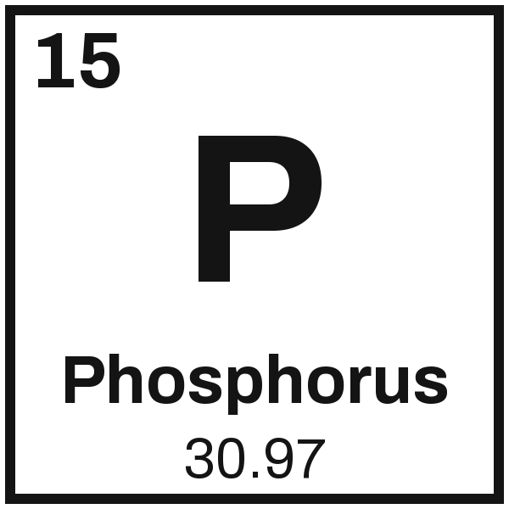  Charge 3−  cation or anion  5 val. e-, gains 3 | 9  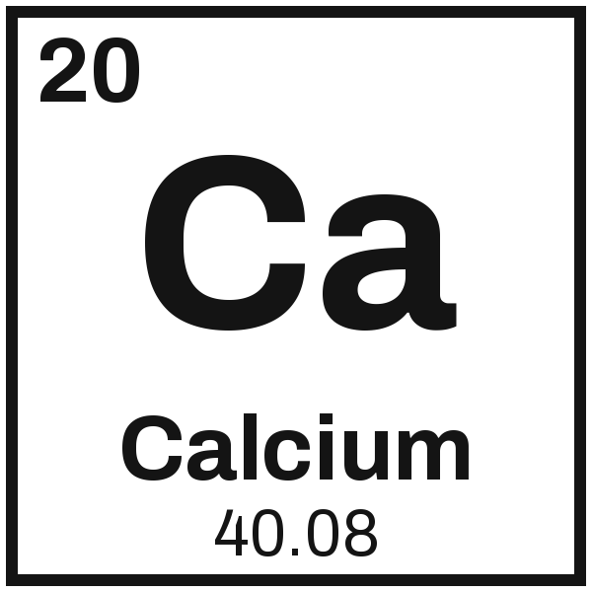  Charge 2+  cation or anion  2 val. e-, loses 2 | 10  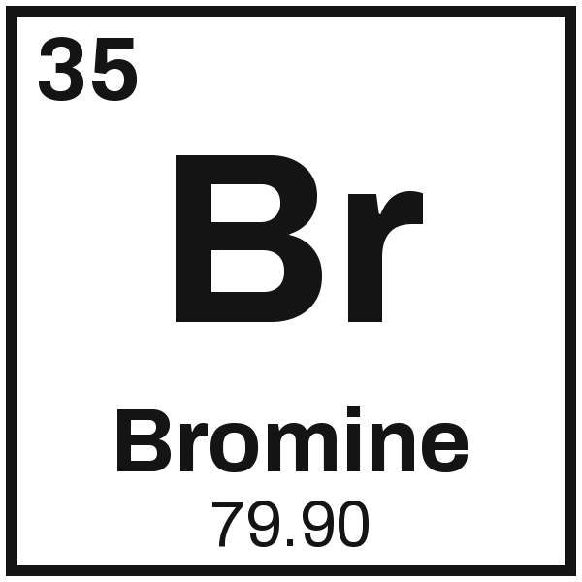  Charge 1−  cation or anion  7 val. e-, gains 1 | 11  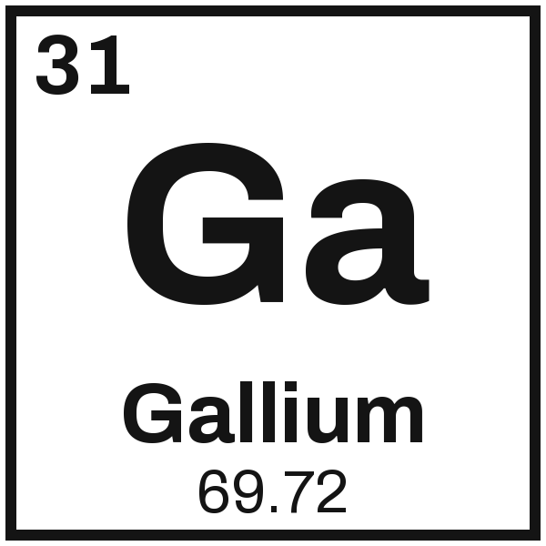  Charge 3+  cation or anion  3 val. e-, loses 3

